Blog introduction

Jackie King is an Early Years Improvement Adviser working for The Education People and recently reviewed some of the online child development training from the DfE. In this blog, Jackie discusses some of the content from the maths module, which she felt provided a great introduction to supporting maths development in young children for new and inexperienced educators. It an excellent refresher for those who are more experienced in early years teaching. The blog provides links to the Education Endowment Foundations Evidence Store and the DfE Help for Practitioners website, which both provide strategies and practical ideas on how to deliver your maths curriculum to our youngest children.

5-minute read -20.10.24

**Meaningful Maths - Supporting Young Children’s Mathematics Development**

Have you looked at the Mathematics module in the DfE Child Development training for practitioners? It was a very interesting reminder of how easy it is to incorporate maths into everyday practice, in ways that support children’s instinctive exploration and interest in mathematical concepts and problem solving as they play. Whilst young children will demonstrate their knowledge and understanding of mathematical concepts through their play, the role of the adult in supporting this is important, as real competency does not just happen. (Copley, 2010)

**Maths and Physical Movement.**

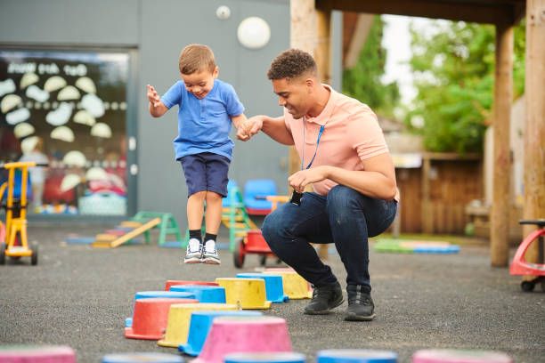Did you know that there is a strong correlation between learning maths and physical movement, especially for boys? Physical movement opportunities are ideal to support mathematics. Counting the stairs as you go up or down, or the number of steps to the sink to wash your hands, talk about positional language and spatial awareness whilst completing an assault course, or weight as children manoeuvre the large tyres in the garden. Use ‘tidy up time’ to help children learn about space, size and position, by using shadows on storage shelves, limiting numbers of items in a basket, so children know where to put things or how many to find. For example, ten cars are stored in the box, we have six, so how many do we need to find?

There are some great videos and written examples on the Education Endowment Foundation (EEF) Evidence Store which show a range of approaches and strategies in action to support your mathematics teaching.  The examples for teaching in the early years, can be applied across different contexts, during adult-initiated and child-initiated opportunities. More information can be found about different ways in which practitioners can approach teaching and support learning in the EEF document ‘Contexts for Teaching and Learning: The Early Years Pedagogical Continuum’, which can be found [here](https://d2tic4wvo1iusb.cloudfront.net/production/documents/pages/EY_Pedagogical_Continuum_0.3.pdf?v=1674479416).

**Patterns in Nature**

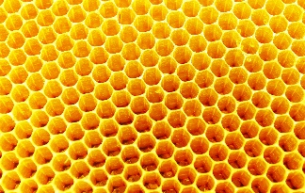Did you know that mathematics and particularly patterns are abundant in nature? Think about the regular, predictable and repeated patterns in honeycomb, rings in an onion, spider webs, shells, leaves and the many more patterns all around us. Research tells us that people are hard wired to respond to patterns, they help us to predict what is coming next, help us to manage our lives, (night follows day, day follows night). Patterns help with transitions and often soothe and reassure us, as we know what to expect.  When children know the pattern of the day, they can predict what comes next, helping them to manage transitions without getting upset or worried.

It is important that young children are in the habit of noticing patterns, as they are more likely to be able to see more complex patterns in maths relationships as they get older. Being able to spot and make patterns when very young, suggests success in maths later. Research also suggests that early maths skills are a more accurate indicator of later academic success than early reading skills (Stipek, Schoenfield, and Gamby, 2012). Pattern can also help children’s developing reading skills; they learn to recognise the pattern in stories, repeated lines form patterns, as does rhyming and this supports children as they learn to predict what comes next. Stories, rhymes and songs are a great way to introduce different types of pattern, for example, a growing pattern is highlighted in an increasing number of characters pulling on The Enormous Turnip. Number rhymes often involve decreasing patterns such as in Ten in the Bed. From a young age, children can begin to predict the next number. Remember to visit the EEF Evidence Store for information and videos of evidence-based practice to support all areas of mathematics teaching.

**The Adult role in Teaching Maths in the Early Years**

Adults should role model enjoying, being fascinated by and engaging in maths as a part of everyday experiences, helping children to develop positive attitudes and interests in maths. Avoid negative comments and stereotyping, “some people are not good at / don’t like maths.” Children must experience positive emotions and feelings, and not be afraid to make mistakes, as we all learn through trial and error. Show children that we all make mistakes, “whoops! I only have four plates and that’s not enough, how many more do I need?” Be playful, make deliberate mistakes, for example, miss a number out when singing counting rhymes, “one, two, four and five, once I caught a fish alive,” children will often enjoy telling you why your counting is wrong, which helps them builds important reasoning skills. You might use a forgetful puppet that needs help to remember how to count, as humour can help reduce children’s anxiety. Demonstrate curiosity and problem solving, for example, ask for help to share out the snack fairly. Be enthusiastic, ask children about their knowledge, “that is five! How did you know?” Use commentary to show your own thinking, “my bottle isn’t full, I wonder how much more water I need to fill it up.”

Remember this famous quote, which demonstrates that getting it wrong is not a bad thing, and the how important it is to ‘keep on trying.’

**“*I have not failed…. just found 10 000 ways that won’t work*,”** (Thomas A. Edison, 1910)

It is important to share your knowledge of how young children learn mathematics with families, to help them to realise the importance of early mathematic skills to support children on their journey through life.

**Final Thoughts**

There is so much more to maths than counting and numbers, sign up to the DfEEarly years child development training and see for yourself. <https://child-development-training.education.gov.uk/>

Find lots of practical tips on implementing evidence-based practice in the EEF evidence store. [Early Years Evidence Store | EEF (educationendowmentfoundation.org.uk)](https://educationendowmentfoundation.org.uk/support-for-schools/evidence-for-the-early-years/early-years-evidence-store)

The Department for Education’s ‘Help for early years providers ‘website also has more ideas for [activities to support mathematics in the early years](https://help-for-early-years-providers.education.gov.uk/mathematics)